Task No: 8a  Date:23/10/25 | Implement basis commands in HIVE.  Tools: HIVE , LINUX / WINDOWS | CO4
AIM:
To install and configure the Apache Hive in windows operating system, and to perform basis commands in HIVE. PROCEDURE:
- Install Java Development Kit (JDK) version 8 or higher.
- Install Hadoop-2.9.2, or use any other STABLE version for Hadoop.
- Install MySQL Query Browser
- Download and install Hive-3.1.2, or use any other STABLE version for Hive.
- Set the environmental variables for HIVE_HOME and Path variables %HIVE_HOME%\bin
- Open a NEW Command Window, check the path settings echo %HIVE_HOME%
- Edit the Properties of hive-site.xml and Replace the value for <Your IP Address> with the IP Address of your System and replace <Your drive Folder> with the Hive folder Path.
- Removing Special Characters and Adding few More Properties in hive-site.xml File.
- Creating Hive User in MySQL Database for reading and writing data from it.
- Grant permission to Users and Creating Metastore
- Starting Hadoop, Hive Metastore and Hive shell prompt start-all.cmd
hive --service metastore
- Open a new cmd window and run the below command to start Hive
> hive
Hive Basic Commands:
Show Databases:
SHOW DATABASES;
Use Database:
USE database_name;
Show Tables:
SHOW TABLES;
Create a Database:
CREATE DATABASE new_database;

Create a Table:
CREATE TABLE my_table ( id INT,
name STRING, age INT
);

Load Data into a Table:
LOAD DATA LOCAL INPATH '/path/to/datafile.csv' OVERWRITE INTO TABLE my_table;

Query Data:
SELECT * FROM my_table WHERE age > 25;

Insert Data into a Table:
INSERT INTO TABLE my_table VALUES (1, 'John', 30);

Describe Table:
DROP TABLE my_table;

Result:
Thus the installation and configuration of Apache Hive and basic commands are executed successfully.

Task No: 8a Date: | Use Hive to create, alter, and drop databases, tables, views, functions, and indexes  Tools: HIVE , LINUX | CO4
AIM:
To Start the Apache Hive in windows operating system, and to execute HQL commands in HIVE.

PROCEDURE:
- Install Java Development Kit (JDK) version 8 or higher.
- Install Hadoop-2.9.2, or use any other STABLE version for Hadoop.
- Install MySQL Query Browser and configure the Hadoop, msql and Hive
- Starting Hadoop, Hive Metastore and Hive shell prompt start-all.cmd
hive --service metastore
- Open a new cmd window and run the below command to start Hive
> hive
- Execute the various Hql Commands in Hive shell
- Stop the hive and other server

HQL COMMANDS:
Create Database
hive> create database demo;
hive> create a database if not exists demo; hive> show databases;
hive> describe database extended demo;
Create Table
hive> create table demo.employee (Id int, Name string , Salary float) row format delimited
fields terminated by ',' ;
hive> create table if not exists demo.employee (Id int, Name string , Salary float) row format delimited

fields terminated by ',' ;

Alter Table
hive> alter table old_table_name rename to new_table_name; hive> Alter table emp rename to employee_data;

Drop Table
hive> drop table new_employee;

Aggregate Functions in Hive
Load the below data file “empl_details” from local drive to HQL table “employee_data” and perform HQL function.
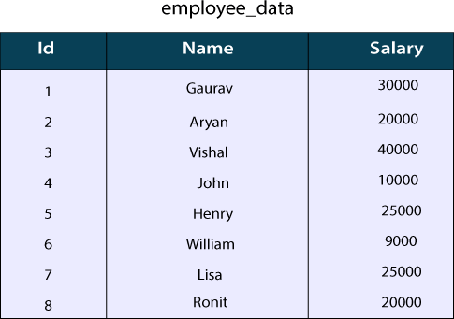

hive> create table employee_data (Id int, Name string , Salary float) row format delimited
fields terminated by ',' ;
hive> load data local inpath '/home/codegyani/hive/emp_details' into table employee_data; hive> select max(Salary) from employee_data;

GROUP BY and HAVING Clause
hive> select department, sum(salary) from emp group by department;
hive> select department, sum(salary) from emp group by department having sum(salary)>=35000;

View and Indexes HQL Views:
Views are generated based on user requirements and save any result set data as a view. hive> CREATE VIEW emp_30000 AS
SELECT * FROM employee WHERE salary>30000;

Dropping a View
hive> DROP VIEW emp_30000;

Creating an Index:

An Index is nothing but a pointer on a particular column of a table. Creating an index means creating a pointer on a particular column of a table.
hive> CREATE INDEX inedx_salary ON TABLE employee(salary) AS 'org.apache.hadoop.hive.ql.index.compact.CompactIndexHandler';

Dropping an Index:
hive> DROP INDEX index_salary ON employee;

RESULTS:
Thus the installation, configuration of Apache Hive and HQL commands are executed successfully.

